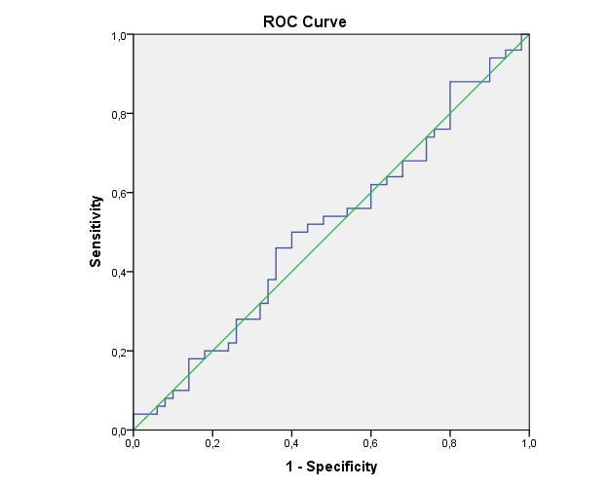

Figure 1: ROC analysis for determining the optimum cut-off TG/HDL-C ratio value for predicting critical coronary artery disease

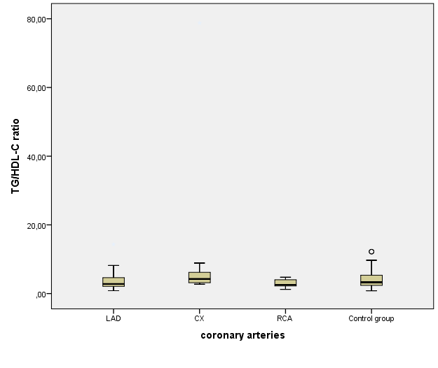
Figure 2: Relationship between the responsible coronary arteries lesion and TG / HDK-C ratio

